**Temperature and humidity transceiver configuration:**

DTH pin configuration

### The DHT11 is chosen because it is lab calibrated, accurate and stable and its signal output is digital. Most important of all, it is relatively inexpensive for the given performance. Below is the pinout of the sensor.

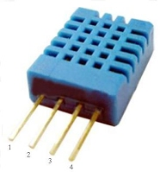

|  |  |  |
| --- | --- | --- |
| Pin | Name | Description |
| 1 | VDD | Power supply 3 - 5.5 V DC |
| 2 | DATA | Serial data output |
| 3 | NC | Not connected |
| 4 | GND | Ground |

**Wiring:**

Connect the sensor to the Arduino as shown below

|  |  |
| --- | --- |
| **DHT11** | **Arduino** |
| Pin 1 | Vcc |
| Pin 2 | Analog0 |
| Pin 4 | Gnd |

RF24: Pin Configuration

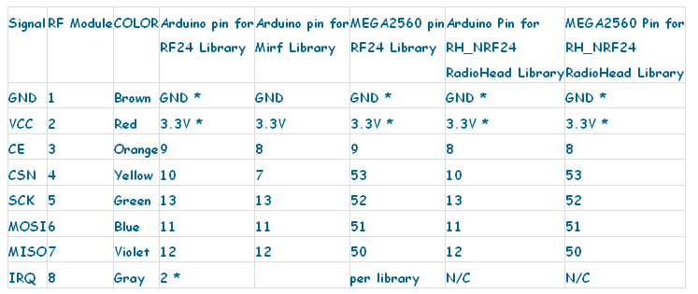

RF24: Sending and receiving messages

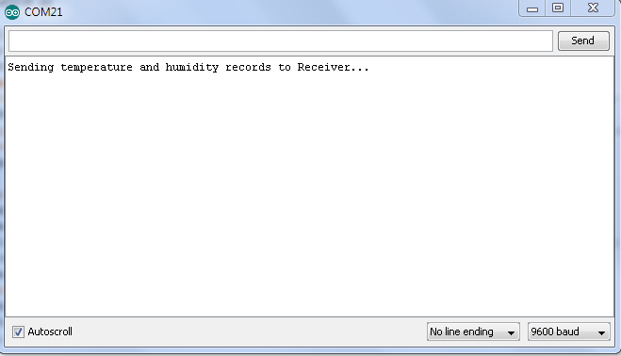

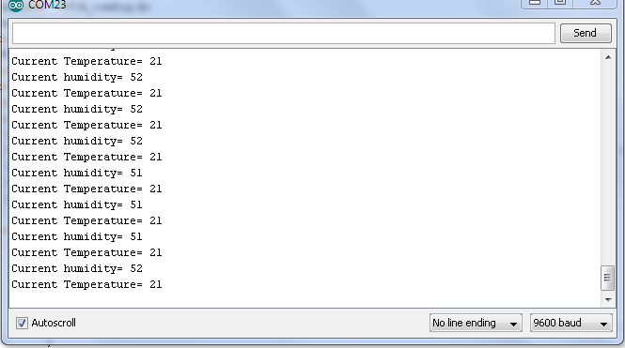

**Reference**:

<http://www.hobbyist.co.nz/?q=documentations/wiring-up-dht11-temp-humidity-sensor-to-your-arduino>

<http://arduino-info.wikispaces.com/Nrf24L01-2.4GHz-HowTo>

<http://shanes.net/another-nrf24l01-sketch-string-sendreceive/>